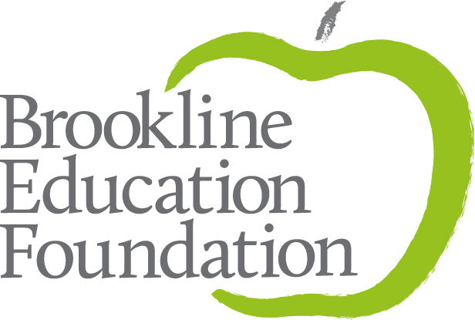

Teacher Grant Application
Deadline: March 9, 2020

INSTRUCTIONS:

- Complete this document, answering all questions on pages 2 - 4. If you would like to be considered for the Charlie Baker Legacy Award, please complete the final page. If not, please just leave blank.

- Once complete, save this document in .pdf or .doc format and include your name in the file name. For example: Joanna Smith Teacher Grant.pdf

- Follow this link to submit an online application and attach this document. If the link doesn’t work, cut and paste this URL into your browser: https://airtable.com/shrZkDKJaqs6L6ERL

- You will need to fill out a short online form, duplicating some of the applicant contact information. At the bottom of the form, you will find a link to upload your completed application.

- Once your grant is submitted, you will receive an email confirmation to acknowledge receipt of the application and that everything uploaded properly. This may take 1 business day.

- The Teacher Grant Committee will review the grants in Late March and Early April. The announcement of successful applications will be made on April 17, 2020 by email.

If you have any questions, or need assistance in uploading your application, please call 617-232-3846 or email Brenda@brooklineeducation.org or Elizabeth_ascoli@brooklineeducation.org.

Thank you for taking the time to apply for a BEF Teacher Grant!

TEACHER GRANT APPLICATION QUESTIONS

APPLICATION DEADLINE: Monday, March 9, 2020 at 5:00 pm

BROOKLINE EDUCATION FOUNDATION
Teacher Grant Application for 2020-2021 Academic Year
Cover Page

APPLICATION MUST BE TYPED

Project Title
Name of Applicant(s)
School and Grades/Subjects You Teach
Telephone Number(s)
Email Address(es)
Years Teaching in PSB,
Total Years Teaching
Amount Requested
Are you applying for the Charlie Baker Legacy Award?
Please list previous BEF grants (year, title, teacher/collaborative)
BROOKLINE EDUCATION FOUNDATION
I understand that, should the Brookline Education Foundation fund my grant application, I am obligated to submit photographs documenting the grant, a written evaluation of my project at its completion and present the results of my grant at a BEF sponsored event. Evaluations of projects completed during the summer will be due by December 31, 2019. Evaluations of projects completed during the school year will be due by May 31, 2020. Photographs may be submitted at any time. I further understand that only educators employed by the Brookline Public Schools at the time the project is undertaken are eligible to receive funds.

Acknowledgement of Applicant(s): Date:

Teacher Grant Application for 2020-2021 Academic Year
Project Description Section

1. Project Summary (1-3 sentences)

- Goal Statement
What are your explicit goals for the project? What would be the best outcome for the work you propose?

3. Context
What experiences (inside or outside the classroom) have led you to apply for this grant?

4. Project Description
Describe the structure of this grant. What is your time frame? When and where will you be working? With whom will you work? You may include copies of supporting material (e.g., conference brochure, tour itinerary). Links to websites may be used for supporting materials and are preferred, if available.

5. Impact
a. Describe as specifically as possible the impact of the work you propose:

- On Yourself - How do you expect this project will change you as an educator? How might this work impact future professional activity?

- On Your Colleagues - What impact will your project have on your professional community, either directly or indirectly?

- On Your Students - How will your students benefit from this project in the short or long term?

b. How will you evaluate the success of this project?

6. Dissemination
How will you share your learning with others in your school and district community? For example, will you share it departmental or school meetings, in an online format, or design other forms of dissemination of your project?
BROOKLINE EDUCATION FOUNDATION
Teacher Grant Application for 2020-2021 Academic Year
Budget and Finances Section

Expense | Purpose | Cost
Consultant
Materials and Supplies
Travel and Accommodations*
please include applicable taxes.
Conference Fee
Other
Substitutes**(please indicate days/hours needed)
TOTAL
* Single rooms are acceptable, if preferred by the applicant.
**The BEF’s ability to pay for subs is limited; requests will be considered on a case-by-case basis.

Please be as specific as possible.

Finances
a. Will there be additional funding from other sources? Please describe.

b. Are resources needed to continue the work of the project after BEF funding ends? If yes, please describe how these resources will be obtained. If no, please describe how the work of the project will be funded or continued after completion of funding by the BEF.

c. Do you foresee any potential challenges /obstacles and, if so, what is your strategy for dealing with them should they occur?

d. Will you be able to complete the project if only partial funding is available? ___Yes ___No
If only partial funding is available, would you be able to redesign the project? ___Yes ___No
Please explain:

e. For groups of three or more educators applying together: If the BEF can fund only a subset of your group,
is there a reason this would pose a problem for you? ___Yes ___No
Please explain:

BROOKLINE EDUCATION FOUNDATION
Teacher Grant Application for 2020-2021 Academic Year
Charlie Baker Legacy Award Section

Charlie Baker Legacy Award If you are applying for the Charlie Baker Legacy Award (fully described in the Call for Proposals), please indicate how the additional $1,000 funding would extend and/or enrich your project. Please limit your response to one page.

