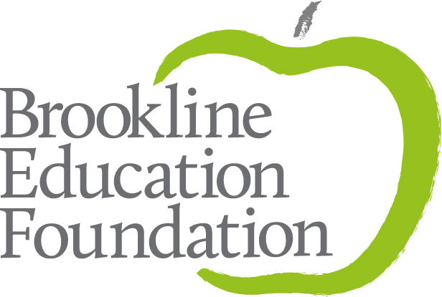

Collaborative Grant Application
Deadline: March 7, 2022

CONCEPT PAPER: If the amount requested is $8,000 or higher you are required to submit a written concept paper to elizabeth_ascoli@brooklineeducation.org no later than January 31, 2022. Concept papers for grants under $8,000 are not required, but are recommended, as the feedback will be useful in preparing your final grant request. The Concept Paper guide can be found on the BEF website at https://brooklinefoundation.org/apply-for-collaborative-grants/.

INSTRUCTIONS:

- Complete this document, answering all questions on pages 1-3.

- Once complete, save this document in .pdf or .doc format and include your name in the file name. Please do not use Pages. For example: Joanna Smith Collaborative Grant.pdf

- Follow this link to submit an online application and attach this document. If the link doesn’t work, cut and paste this URL into your browser: https://airtable.com/shrcWVLaTRTd0e1CP

- You will need to fill out a short form duplicating some of the applicant contact information, and then you will need to upload your completed application using the link provided at the bottom of the form.

- Once your grant is submitted, you will receive a confirmation to acknowledge receipt of the application.

- The Collaborative Grant Committee will review the grants in late March/early April and announcement of successful applications will be made in April, 2022.

If you have any questions, or need assistance in uploading your application, please call 617-232-3846 or email jennie@brooklineeducation.org or elizabeth_ascoli@brooklineeducation.org.

COLLABORATIVE GRANT APPLICATION

*APPLICATION DEADLINE: Monday, March 7, 2022 at 5:00 pm

BROOKLINE EDUCATION FOUNDATION
Collaborative Grant Application for 2022-2023 Academic Year
Cover Page

***PLEASE NOTE: CONCEPT PAPER REQUIRED FOR GRANTS OVER $8,000 DUE: Jan 31, 2022***

APPLICATION MUST BE TYPED

Project Title
Who is the Project Leader?
Leader’s School/Assignment
Leader’s Home Telephone Number
Leader’s Email Address
Years teaching in PSB;
total years teaching
Project period
Amount requested

I understand that, should the Brookline Education Foundation fund this Collaborative Grant application, as Project Leader, I am obligated to submit photographs documenting the grant, a written evaluation of this project at its completion and to present the results of my grant at a BEF-sponsored event. Evaluations of projects will be due by May 31, 2023. I further understand that only educators employed by the Public Schools of Brookline at the time the project is undertaken are eligible to receive funds.

Acknowledgement of Project Leader: Date:

For online submissions, please acknowledge that you have read and agreed to the above statement. ____

BROOKLINE EDUCATION FOUNDATION
Collaborative Grant Application for 2022-2023 Academic Year
Project Description Section

- Project Summary (1-3 sentences)

2. Need
Why is this project needed?

3. Personnel
a. In addition to the project leader, who are the participants in this grant? Please include names, schools, assignments, and email addresses.

b. What administrator/principal/headmaster/curriculum coordinator is responsible and accountable for project activities?

c. Will the project require additional personnel or reassignment of current staff?

4. Goal Statement
What are the explicit goals for the project?

5. Context
What are the experiences of the participants (inside and/or outside the classroom) that have led you to apply for this grant?

BROOKLINE EDUCATION FOUNDATION
Collaborative Grant Application for 2022-2023 Academic Year
Project Description Section

6. Project Description
a. Describe the structure of this grant: what is your time frame, when and where will you be working, with whom will you work? You may include copies of supporting material (e.g., conference brochure, tour itinerary). Links to websites may be used for supporting materials and are preferred, if available.

b. Tell us about the collaborative aspect of this grant.

7. Impact and Evaluation

a. Describe as specifically as possible the impact of the work you propose:
- On Yourselves - How do you expect this project will change you as educators? How might this work impact future professional activities?

- On Your Colleagues - What impact will your project have on your professional community either directly or indirectly?

- On Your Students - How will your students benefit from this project in the short or long term?

b. How will you evaluate the success of this project?

7. Dissemination
How will you share your learning with others in your school and district community? For example, will you share it departmental or school meetings, in an online format, or design other forms of dissemination of your project?

8. Multi-year projects
If this application is part of a multi-year project, please put this application in context (to be completed only when applying for a second year of funding).

a. Please evaluate the first year of your grant (see the evaluation form here: https://airtable.com/shrzv6ByC2ZLfOunY

b. How does this year build on what was accomplished in the preceding year?

c. What are the plans and anticipated budget for next year?

BROOKLINE EDUCATION FOUNDATION
Collaborative Grant Application for 2022-2023 Academic Year
Budget and Finances Section

Please provide a detailed budget. Be as specific as possible.

Expense | Purpose | Cost
Stipends
($33 per hour per participant)
Consultant
(Include name and location)
Materials and Supplies
Travel and Accommodations*
please include applicable taxes
Conference Fee
Other
Substitutes **(please indicate days/hours needed--$110/day)
TOTAL
* Single rooms are acceptable if preferred by the applicant.
**The BEF’s ability to pay for subs is limited; requests will be considered on a case-by-case basis.

Finances
a. Will there be additional funding from other sources? Please describe.

b. Are resources needed to continue the work of the project after BEF funding ends? If yes, please describe how these resources will be obtained. If no, please describe how the work of the project will be funded or continued after completion of funding by the BEF.

d. Will you be able to complete the project if only partial funding is available? ___Yes ___No
If only partial funding is available, would you be able to redesign the project? ___Yes ___No
Please explain:

